BUSINESS, WEB AND SOCIAL MEDIA ANALYSIS
CRN - 48449
Case Study – 2
NAME: ADITYA SHROFF & Shreya Sahal
COLLEGE ID: 101539669
DATE: 01/04/2025

PART – 1

DATA PROCESSING

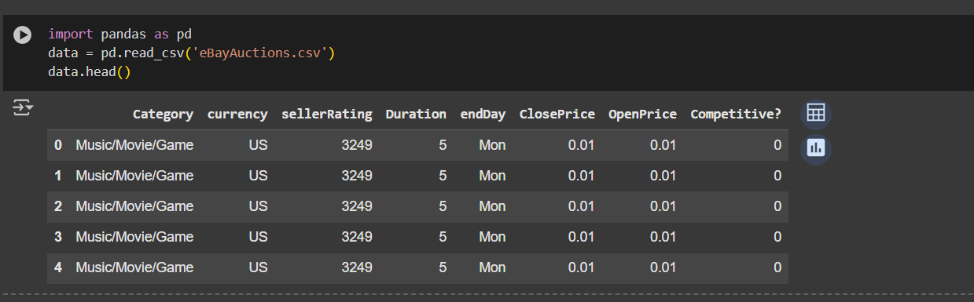

CONVERSION OF DURATION INTO CATEGORICAL VARIABLE

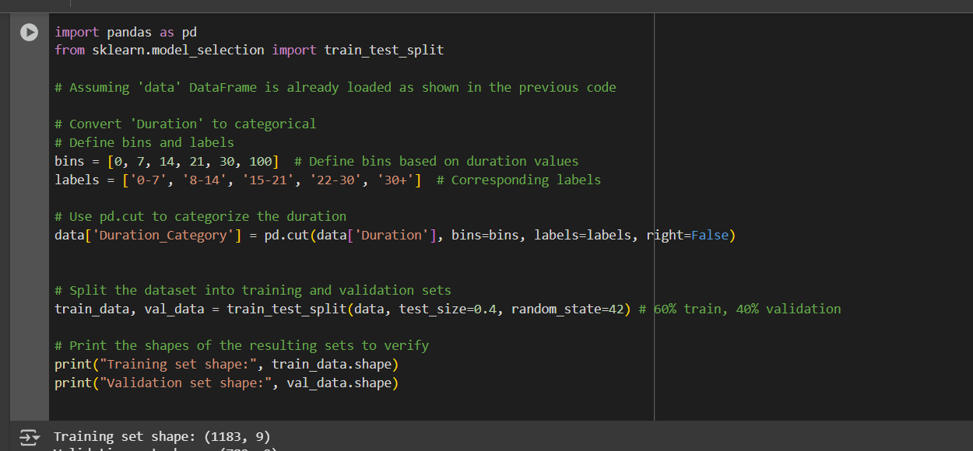

DECISION TREE:

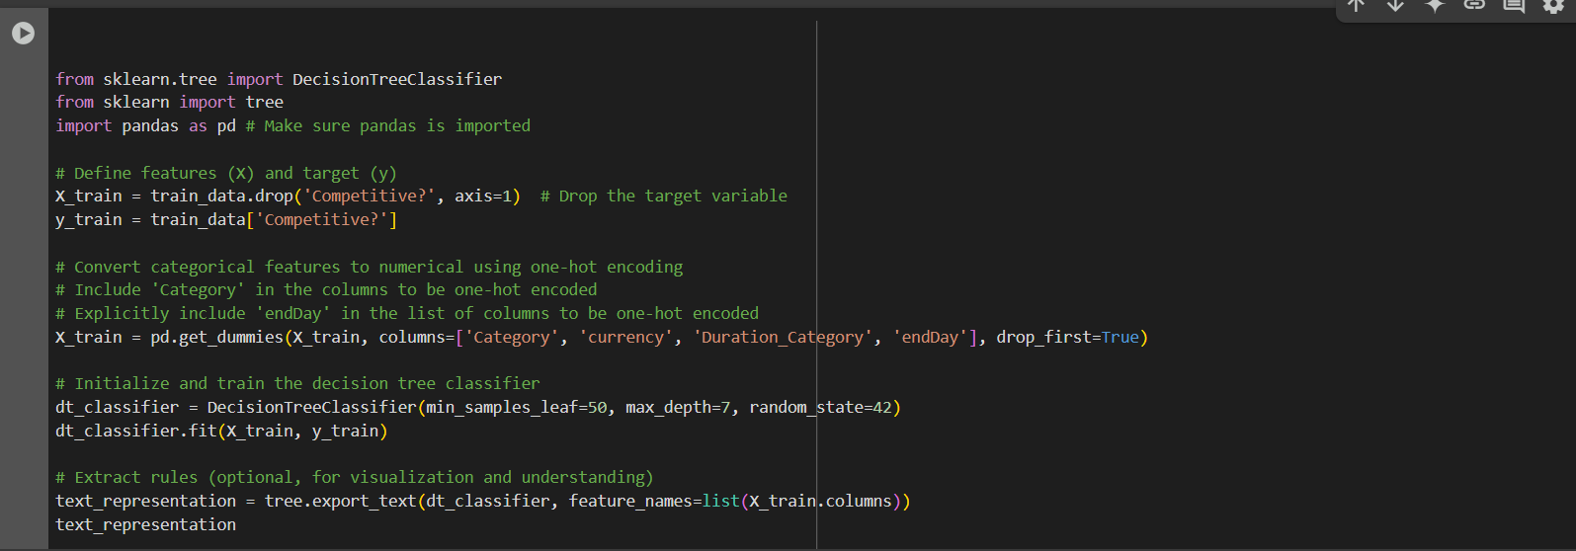

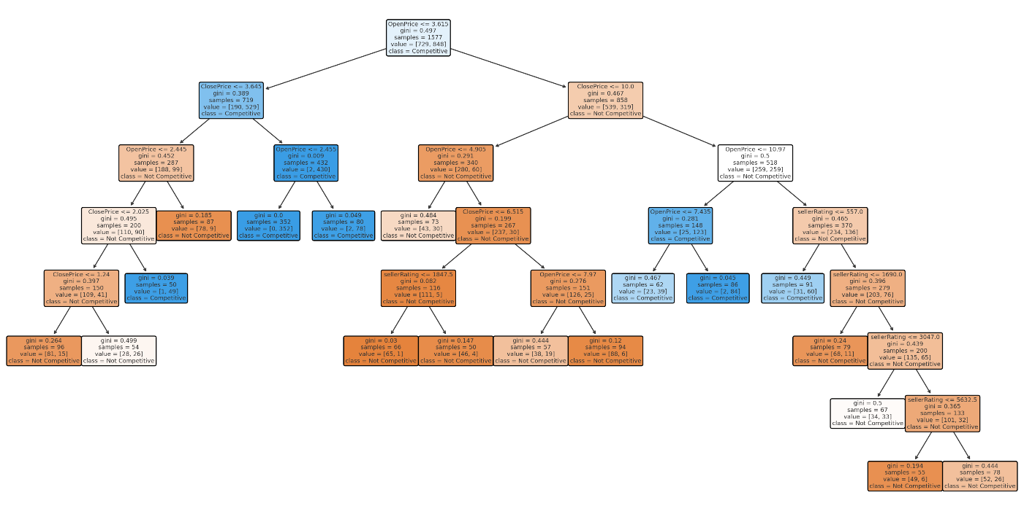

MODEL EVALUATION AND VISUALIZATION :

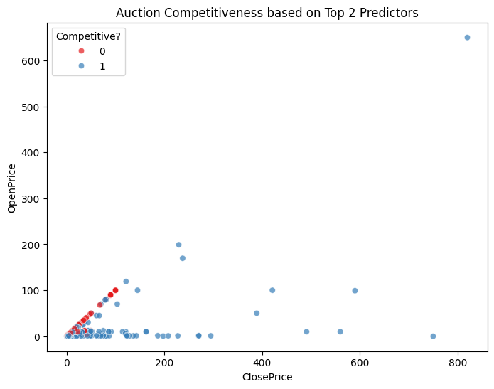

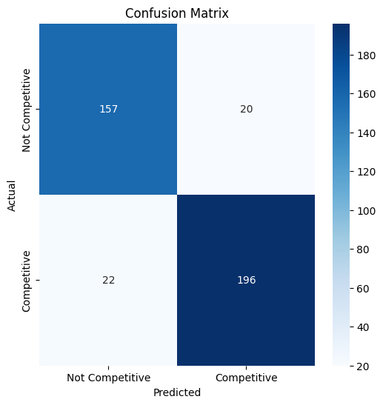

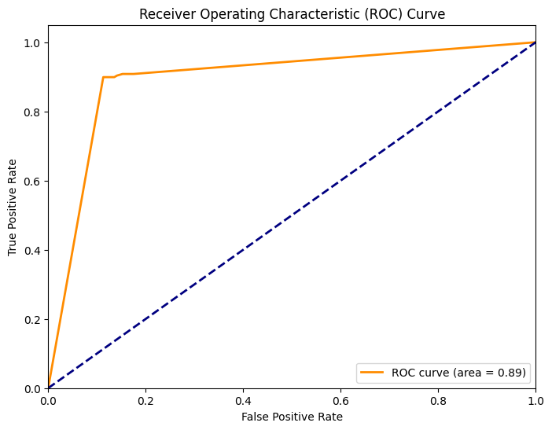

eBay Auction Competitiveness Analysis: A Data-Driven Approach
Introduction
This report presents the findings of an analysis conducted to identify key factors influencing the competitiveness of eBay auctions. We employed a decision tree model to uncover patterns and relationships within historical auction data. The insights gained from this analysis are used to provide actionable recommendations for optimizing auction settings to maximize bidder engagement and selling prices.
Methodology
- Data Preparation: The dataset, "eBayAuctions.csv," was pre-processed to handle categorical variables and split into training and validation sets (60% and 40%, respectively).
- Decision Tree Model: We trained a Decision Tree Classifier using the sklearn library in Python. Hyperparameters were set to min_samples_leaf=50 and max_depth=7 to avoid overfitting. The model was fitted using all relevant predictors, including opening price, closing price, seller rating, and item category.
- Feature Importance: We evaluated the importance of each feature in the decision tree model to understand which factors most strongly influence auction competitiveness.
- Decision Rules Extraction: The decision rules of the trained tree were extracted to identify specific patterns and thresholds associated with competitive and non-competitive auctions.
- Recommendation Formulation: Based on the insights gleaned from the model, we developed actionable recommendations for setting auction parameters to maximize competitiveness.
Key Findings
- Price is a Primary Driver: The opening and closing prices of an auction are strongly correlated with its competitiveness. Very low starting prices often lead to non-competitive auctions, while moderate to higher prices tend to attract more bidders, especially when accompanied by strong seller reputations.
- Seller Rating Matters: For higher-value items, the seller's rating becomes a significant factor in influencing competitiveness. Buyers are more likely to engage in bidding wars for items sold by reputable sellers.
- Category Considerations: While less prominent than price and seller rating, the item's category can subtly impact competitiveness. Specific categories, such as Automotive, exhibit unique price sensitivities that should be considered when setting opening bids.
Recommendations
Based on the decision tree analysis, we recommend the following auction settings to maximize competitiveness:
Starting Price (OpenPrice):
- Moderate-Value Items: Set your starting price between $3.62 and $3.62 and $10.49 to encourage bidding.
- High-Value Items: If you have a strong seller rating and are offering a premium item, consider a starting price above $10.49. * **Avoid: ** Starting prices below $$10.49. * **Avoid: ** Starting prices below $3.62, as they often discourage bidders.
Duration:
- Opt for a 7- or 10-day auction duration for optimal bidder engagement.
Ending Day:
- Target: Weekdays or evenings when potential buyers are most active.
- Avoid: Ending auctions on major holidays or weekends when engagement is typically lower.
Beyond the Basics:
In addition to these core settings, remember to:
- Build a Stellar Reputation: Maintain a high seller rating to inspire buyer confidence.
- Craft Compelling Listings: Use clear descriptions and high-quality images to attract bidders.
- Stay Informed: Monitor market trends and competitor strategies to adapt your approach.
Conclusion
By strategically applying these insights and recommendations, eBay sellers can significantly enhance the competitiveness of their auctions, attract more bidders, and achieve higher selling prices. This data-driven approach empowers sellers to make informed decisions about their listing strategies and optimize their chances of success in the online marketplace.

PART – 2

DATA PROCESSING AND TRAINING

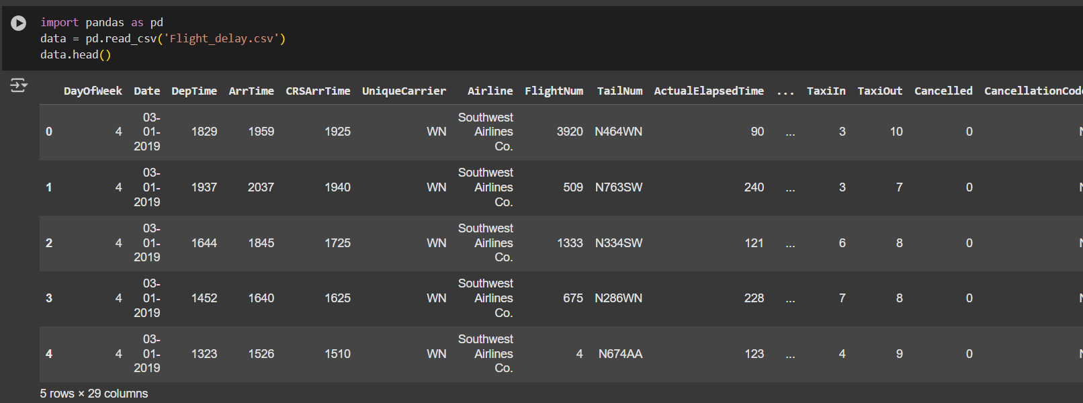

Fit a classification tree with maximum depth = 8 and minimum impurity decrease = 0.01.



IDENTIFYING TOP 3 FEATURES THAT CAUSES FLIGHT DELAYS

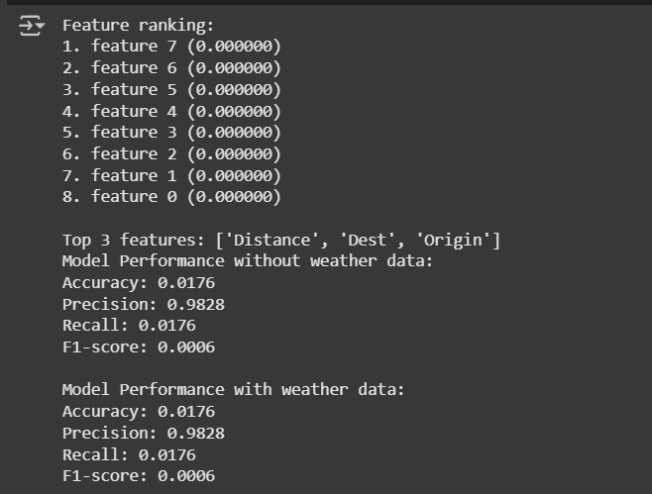

EXPLORATORY DATA ANALYSIS

  - Finding out missing values in the column

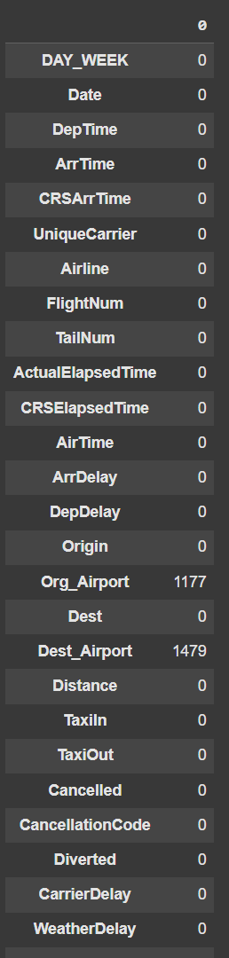
Out of 29, there are 19 Numerical variables rest of them are categorical

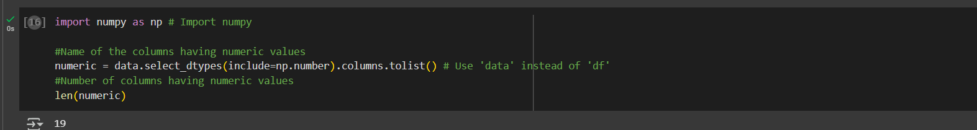

Separating Delay into another data frame

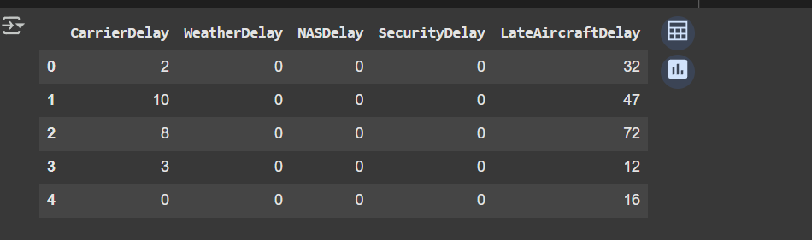



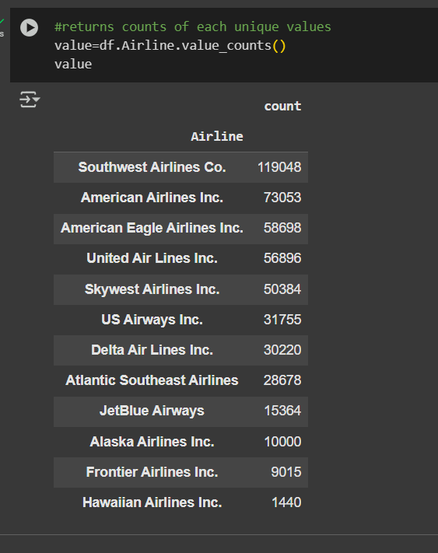

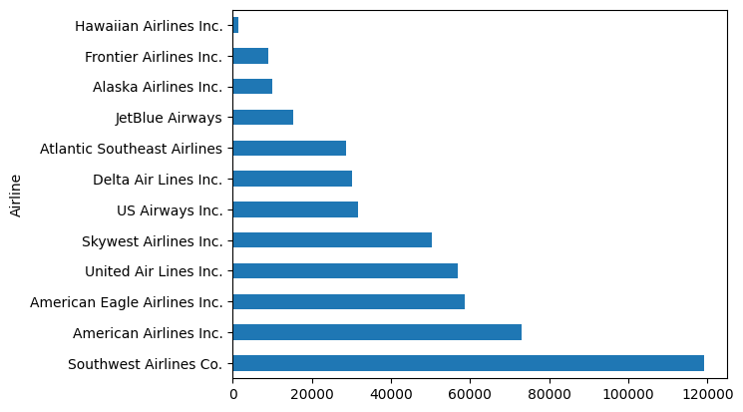

Delays on various days of the week

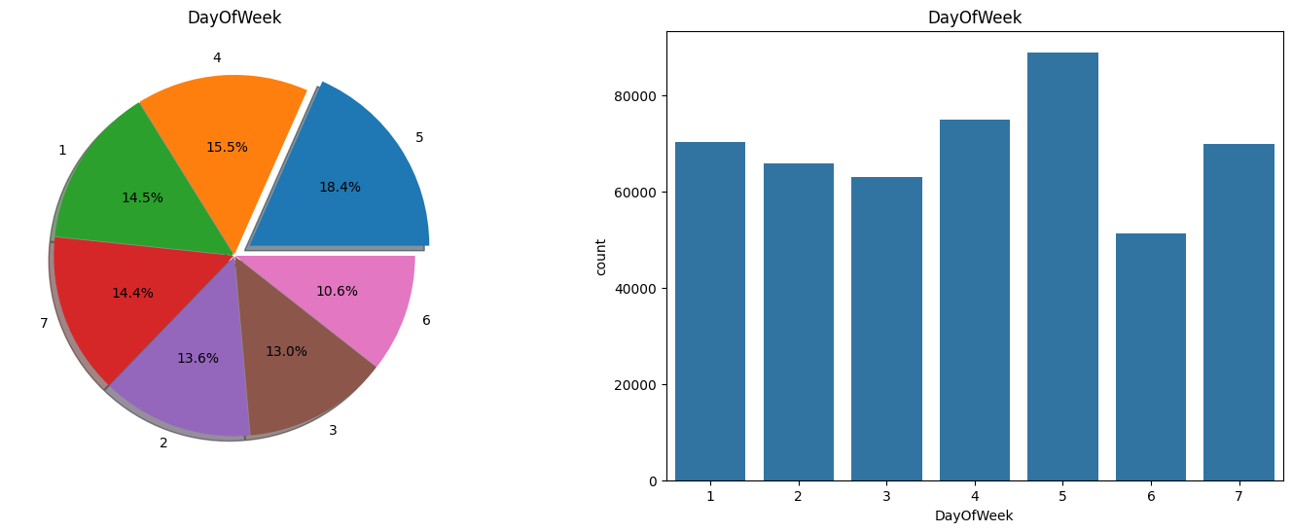

On which time delay happens mostly?

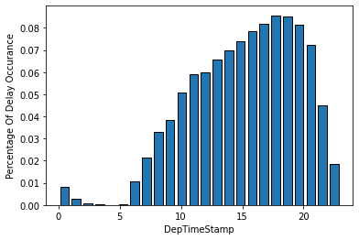

Correlation Matrix

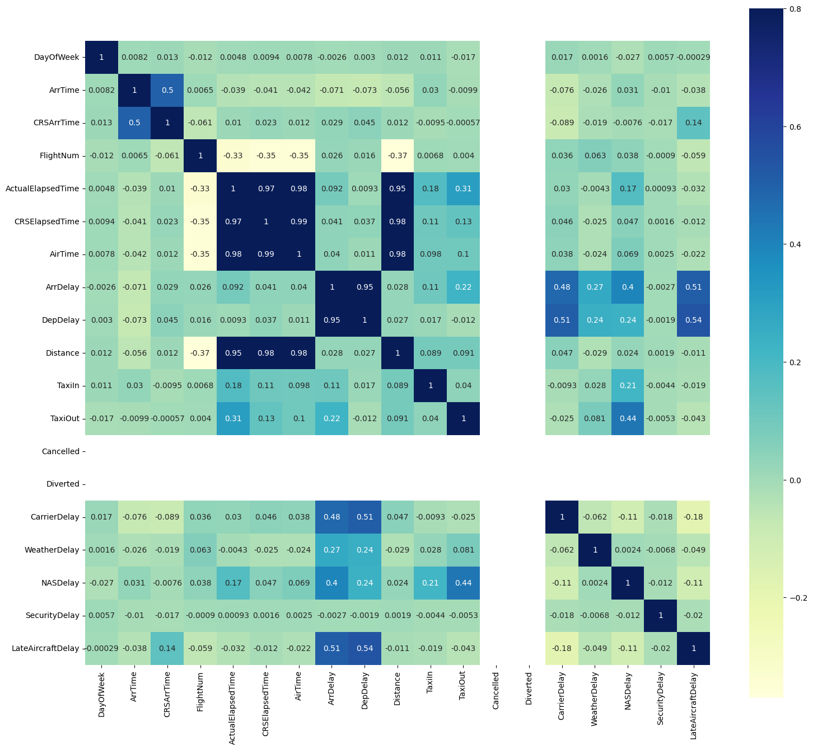

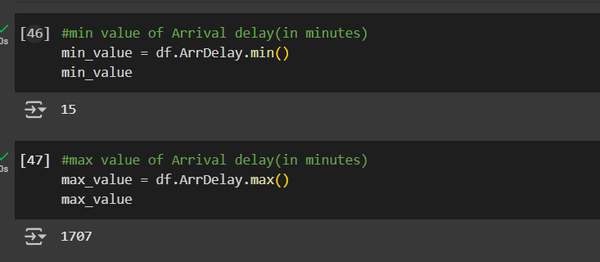

INSIGHTS
- All the flights in the data of this dataset, have at least any one of the delays.

- Southwest Airline company has the largest number of travel delay records

- The maximum number of delays happened on FRIDAY

  - A High Percentage of Delay occurs between 15:00:00 to 20:00:00 (i.e.) 3 PM to 8 PM.

- The flights scheduled to depart at 3 PM to 8 PM delays mostly

- The flights scheduled to depart at 12 AM to 5 AM - a smaller number of delays

- Data is available for First half of the year 2019. From that first 6 months, March month has more delay records

- Most of the delays are short timed. Compared to short time delay, minority of the delays are long timed.

- The minimum Arrival delay is 15 Minutes & The maximum Arrival delay is 1707 Minutes

- Chicago O'Hare International Airport is the airport where most frequently flights depart and arrive

- American Eagle Airlines has taken the highest time in minutes for the carrier delay.

- American Airlines Inc. has taken the highest time in minutes for the weather delay.

- American Airlines Inc. has taken the highest time in minutes for the NAS delay.

- Atlantic Southeast Airlines has taken the highest time in minutes for the Security delay.
- United Airline Inc. has taken the highest time in minutes for the Late Aircraft delay.

- Late Aircraft delay, Carrier Delay, and NAS delay shows most delay during the year.

- Carriers with higher average delay generation are Hawaiian Airlines (HA) with 36.41 minutes per flight, Atlantic Southeast Airlines (EV) with 33.60 minutes per flight

- The locations with high delay rates have very few flights. The locations with low delay rates have very high number of flight counts.

Part 3

Title: Predicting Used Car Prices Using Regression Trees

1. Introduction
This report presents a data-driven approach to predicting the prices of used Toyota Corolla cars using regression trees. The primary objective is to identify the most influential features affecting car prices and to build a predictive model that can estimate prices based on vehicle characteristics. Regression trees are particularly effective for this task due to their interpretability and ability to handle nonlinear relationships.

2. Methodology
2.1 Data Preprocessing
- Dataset: ToyotaCorolla.csv
- Removed irrelevant columns: Id, Model
- Converted categorical variable Fuel_Type into dummy variables using one-hot encoding
- Checked for and confirmed absence of missing values
- Split dataset into training (60%) and validation (40%) sets for model evaluation
2.2 Exploratory Data Analysis (EDA)
To better understand the target variable (Price), a histogram was plotted:
Figure 1: Distribution of Used Car Prices
Shows the frequency of various price points. Most cars are clustered between 10,000 and 15,000.



3. Model Development
3.1 Regression Tree Training and Tuning
A DecisionTreeRegressor from Scikit-learn was used for training. Grid search with 5-fold cross-validation was applied to find the optimal tree depth (max_depth from 2 to 15).
- Best Tree Depth: 6
- Training RMSE: ~859
- Validation RMSE: ~1228
These RMSE values indicate that the model fits the training data well and maintains reasonable predictive accuracy on unseen validation data, with minimal overfitting.
3.2 Feature Importance Analysis
The trained tree's feature importance was extracted. The top 3 predictors of price were:
- Age_08_04 – Older cars depreciate more, hence have lower prices.
- Weight – Generally heavier cars tend to have more features and higher pricing.
- KM – Higher mileage tends to decrease value.
Figure 2: Top 10 Feature Importances
Displays which attributes the model relied on the most when making predictions.


3.3 Predicted vs Actual Comparison
To visually assess model performance, predicted prices were plotted against actual prices for the validation set.
Figure 3: Actual vs Predicted Car Prices
A near-diagonal line indicates close prediction to actual values.

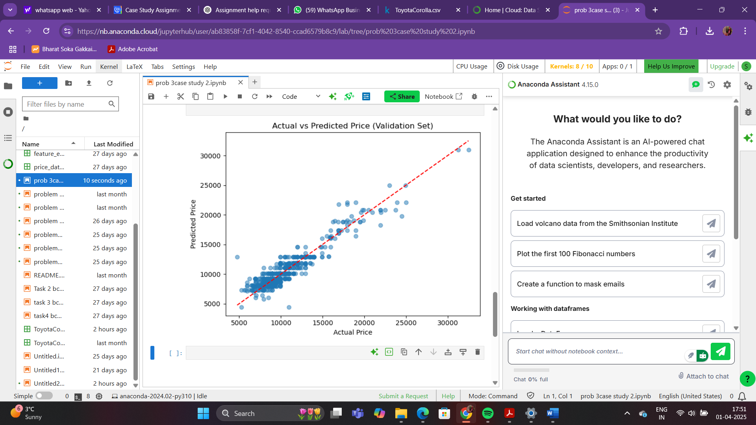

4. Results & Interpretation
- The regression tree model provided interpretable results with clear insights into what features drive car prices.
- Age of the vehicle was the single most important predictor, followed by Weight and KM.
- RMSE values showed a decent fit, with some overfitting manageable by pruning or regularization in future models.

5. Conclusion & Recommendations
Conclusion
This study confirms the effectiveness of regression trees in estimating used car prices. The model's interpretability allows businesses to understand what drives pricing decisions.
Recommendations
- Include more features like car condition, service history, or accident record for even better predictions.
- Explore ensemble methods like Random Forests or Gradient Boosted Trees to potentially improve accuracy.
- Keep models updated with recent data to maintain accuracy in changing market conditions.

Appendix
- Full Jupyter Notebook: prob 3case study 2.ipynb
- Dataset: ToyotaCorolla.csv
- Plots:
  - Figure 1: Histogram of Car Prices
  - Figure 2: Top 10 Feature Importances
  - Figure 3: Actual vs Predicted Prices

